*Living by a budget isn’t just for people who have debts to pay. Jesus shares that Kingdom people should “count the cost” before starting to build a house. A budget is a way to spend, and save, wisely for the Kingdom of God.*

1. **You need to know your income.** If you are going to make a budget, you need to know what your monthly income will be.
2. **Determine budget percentages:** Using the chart on the following page, look at the recommended percentages that you should consider spending in each part of your budget. These are important. If you over-spend in one area, it will squeeze you in other areas. You need to set a target percentage for each area using the guidelines that are provided by Dave Ramsey. Then see how much that percentage is in real dollars. The total percentages you allocate cannot exceed 100% (This may be obvious, but it doesn’t hurt to state the obvious).
3. **Give every dollar a name and make it obey:** Now divide those real dollars up in the categories. You will see a form on the page after the chart that details what goes under the housing category, the transportation category, etc. Your goal is to give every dollar a name and make it obey! The more specific your budget is the more helpful it will be. I used to have an amount allocated under miscellaneous for haircuts...that is pretty detailed.
4. **Smoothing expenses:** Think about what expenses you will have irregularly or infrequently. This can include money you will spend on Chi Alpha retreats, Christmas presents, vacations, car repairs, etc. You know these things are going to happen and will be substantial to your budget when they do happen. So, think about how much you typically spend annually on each category and then divide that amount by 12. This will tell you how much you should budget monthly for that expense. When you get paid, transfer the amounts you are saving for each of these to your savings account. If you don’t have a savings account, you should open one (the “extra” money sitting in your checking account is too tempting to spend if you leave it there). Then when these expenses occur, you will simply take the money out of savings. If you fail to plan for these expenses, you will be planning to fail. These are often the expenses that take us into debt and cause us to revert to using credit cards.
5. **Envelope method:** Once you have established your budget now it is time to actually use it! For items on your budget that happen throughout the month (expenses that are not just writing a check once a month), I encourage you to go to the bank after pay day and take out cash for each of these categories. Then go home and put cash in an envelope for each category. When it is time to go to the grocery store, take cash out of the grocery envelope. When it is time to get gas, take cash out of the gas envelope, when it is time to go out to eat, take money out of the eating out envelope, etc. When the cash for each category is gone for the month, it’s gone—no transferring money between envelopes! If you do this, you will not overspend on the categories. It is one thing to make a budget; it is another to live on it.
6. **Evaluate** your budget after a few months to see if the amounts are feasible or if there needs to be some changes.
7. **Build an emergency fund as soon as possible:** For starters try to save $1,000 as fast as you can. This will help when an unexpected expense comes your way. If you have an emergency fund you will not have to go in debt to pay for the unexpected expense. If you do not have an emergency fund, you will have to go in debt. So, save $1,000 as fast as you can. The ultimate goal will be to accumulate 2 to 3 months of expenses in your savings, in case you were to be laid off, or some other financial difficulty were to come your way.

**Other tips:**

* Make sure you start practicing generosity through budgeting tithing and supporting missions.
* Make sure you start saving for retirement immediately after graduation.

**Budgeting Percentages From Dave Ramsey**

*This resource is adapted from Dave Ramsey, a financial advisor and author. This will help you begin to develop and live on a budget. For further reading, read his books (i.e. Total Money Makeover or Financial Peace).*

The far left column lists some basic categories that comprise an individual’s (or family’s) budget. Ramsey’s recommended budgeting percentages are listed in the second column (“Recommended %). After examining Ramsey’s recommended percentages per category, determine your ideal percentage to spend in each category. Record these percentages in the third column (“Ideal %”), making sure that the sum of all the categories is 100 percent.

Then you will need to record your total monthly income (as an individual, or family). If you do not already live by a budget (not just *have* a budget, but *live* by it), you will need to record all your spendings for at least one month, categorizing them along the way. Record these totals in the fourth column by category (“Actual Money Spent”). If you already have a working budget, enter the budgeted amounts in this column by category.

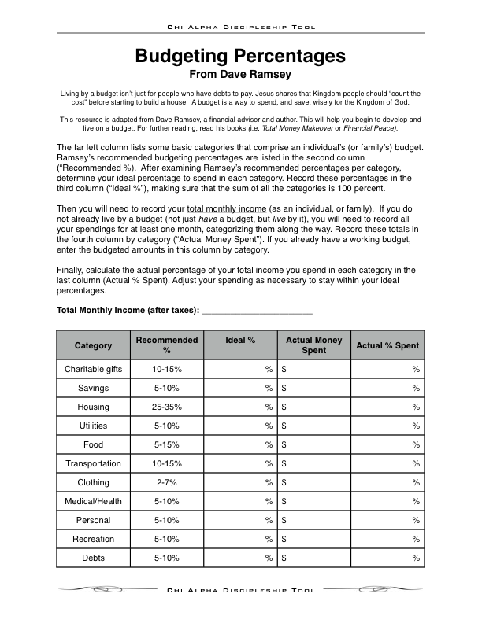Finally, calculate the actual percentage of your total income you spend in each category in the last column (Actual % Spent). Adjust your spending as necessary to stay within your ideal percentages.

**Monthly Income and Expenses**

|  |  |  |  |  |
| --- | --- | --- | --- | --- |
| **Income Per Month (Before Taxes)** | | | | |
| Salary | | ___________ | | |
| Other | | ___________ | | |
| **Total:** | | ___________ | | |
|  | |  | | |
| Tithe | | ___________ | | |
| Taxes | | ___________ | | |
|  | |  | | |
| Now subtract tithe and taxes from your total monthly income: | | | | |
| **Spendable Income (After Taxes):** | | ___________ | | |
|  | |  | | |
|  | |  | | |
| **Expenses Per Month** | | | | |
| **Housing** | |  | | |
| Rent | | ___________ | | |
| Insurance | | ___________ | | |
| Electricity | | ___________ | | |
| Gas | | ___________ | | |
| Water | | ___________ | | |
| Sanitation | | ___________ | | |
| Phone | | ___________ | | |
| Internet | | ___________ | | |
| Other | | ___________ | | |
| **Food** | |  | | |
| Groceries | ___________ | | |
| Eating Out | ___________ | | |
| **Clothing** | | ___________ | | |
| **Savings** | | ___________ | | |
| **Medical Expenses** | | ___________ | | |
| **Car** | |  | | |
| Payment | | ___________ | | |
| Insurance | | ___________ | | |
| Gas | | ___________ | | |
| Maintenance | | ___________ | | |
| **Charitable Giving (Beyond Tithe)** | | ___________ | | |
| **Entertainment** | | ___________ | | |
| **Miscellaneous** | |  | | |
| Toiletries/Cosmetics | | ___________ | | |
| Laundry/Cleaning | | ___________ | | |
| Gifts | | ___________ | | |
| Cash | | ___________ | | |
| Other | | ___________ | | |
| **Total Expenses:** | | ___________ | |
| **Spendable Income (After Taxes):** | | ___________ | |
|  | | | |
| Now subtract your total expenses from your spendable income: | | | |
| **Unallocated Surplus:** | |  | |